**Day 1 :Installation**

**Download, Install and configure**

Download -> Install -> configure path in system environment variables

* Java

<https://download.oracle.com/java/21/archive/jdk-21.0.5_windows-x64_bin.exe>

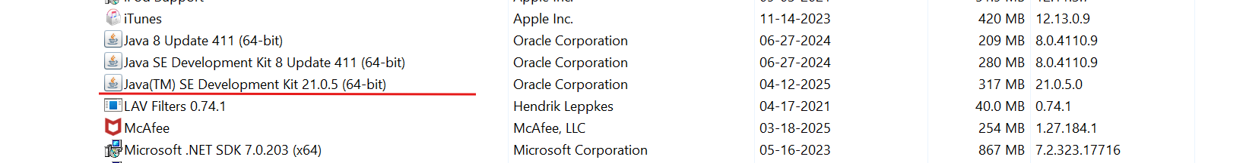

* Git

<https://github.com/git-for-windows/git/releases/download/v2.49.0.windows.1/Git-2.49.0-64-bit.exe>

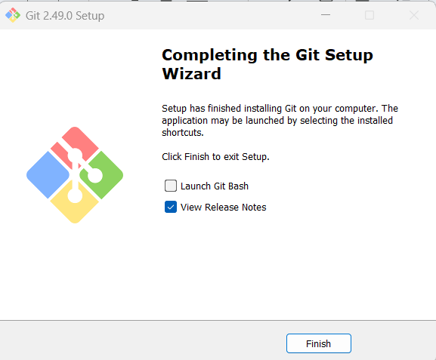

Download --> configure path in system environment variables

* Maven

<https://dlcdn.apache.org/maven/maven-3/3.9.9/binaries/apache-maven-3.9.9-bin.zip>

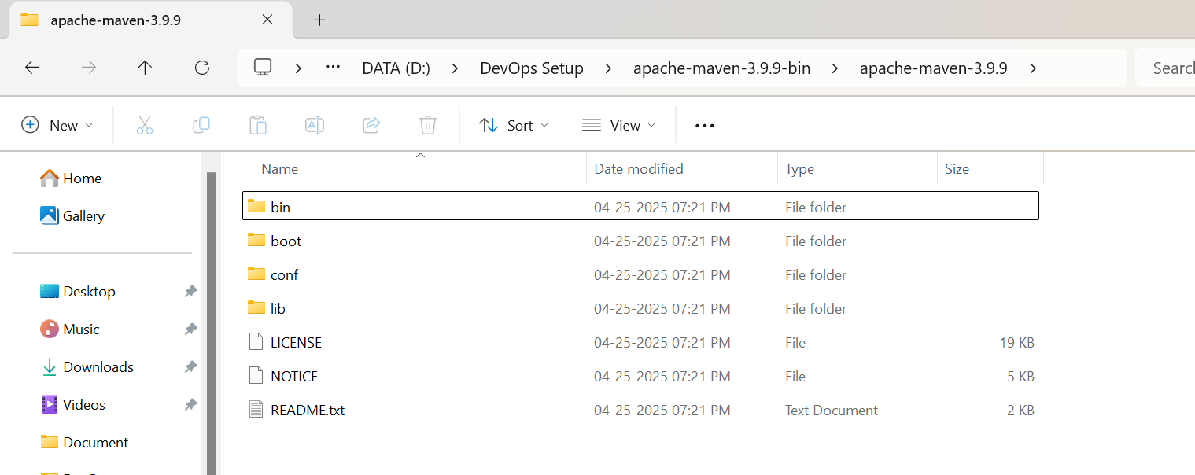

* Terraform

<https://releases.hashicorp.com/terraform/1.11.4/terraform_1.11.4_windows_386.zip>

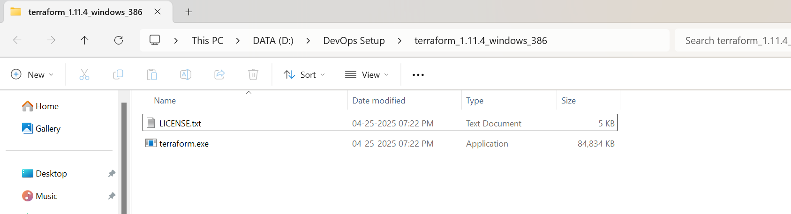

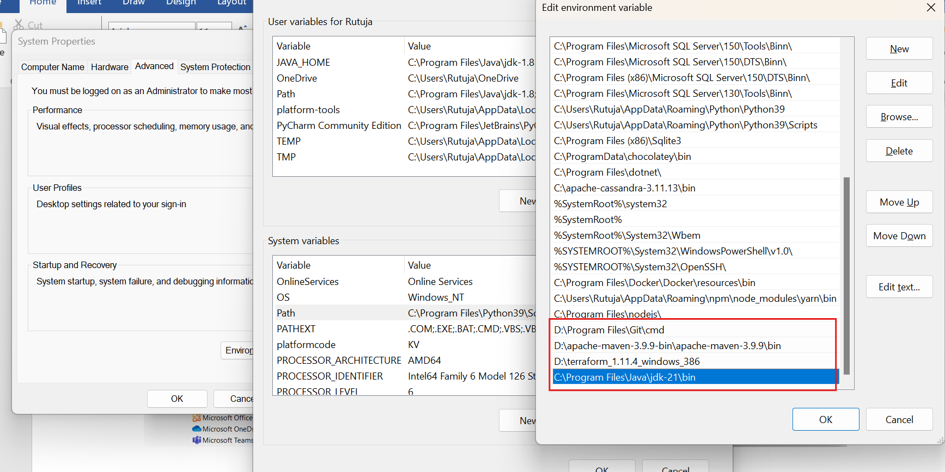

**Validate the installation:**

>java --version

>mvn --version

>git --version

>terraform --version

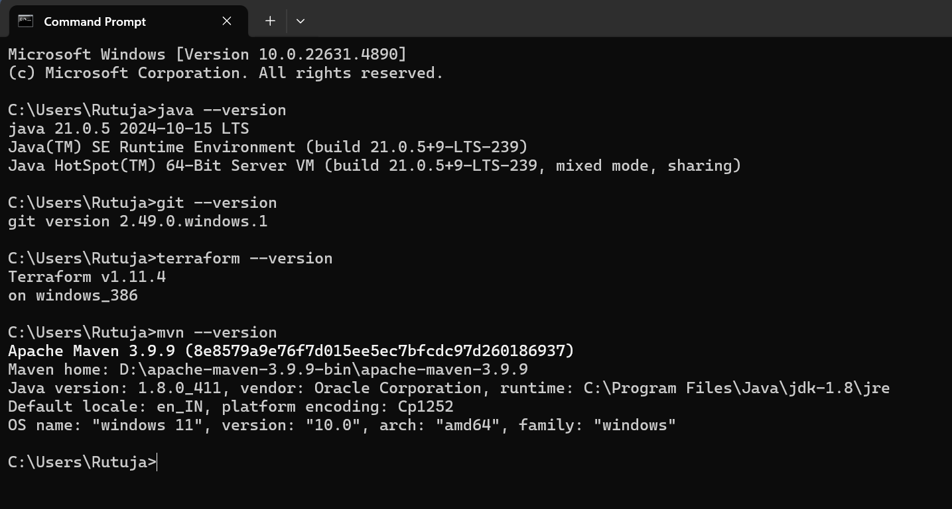

**Install IntelliJ IDEA & VSCode:**

IntelliJ IDEA Community Edition

<https://www.jetbrains.com/idea/download/?section=windows>

VSCode

<https://code.visualstudio.com/download>

**Create accounts:**

* AWS account
* Github Account
* Docker hub account